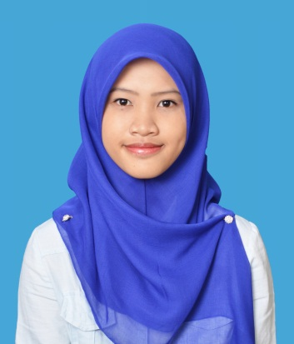

**NORLELA BINTI MISRI**

PERSONAL DETAILS

Address : Pos 321, Kampung Sungai Nibong, 83600 Semerah, Batu Pahat, Johor.

IC No. : 931029-01-6264

Gender : Female

Age : 23 years old

Date of Birth : 29 October 1993

Telephone No. : 017-7279667

Email Address : [lelamisri93@gmail.com](mailto:lelamisri93@gmail.com)

EDUCATION BACKGROUND

**Bachelor**

Field of Study : Business Management (Hons) **Operation Management**

Institute/University : UiTM Kampus Puncak Alam

Grade : 3.07 (Current)

Graduation Date : On November 2017

**Diploma**

Field of Study : Business Management – **Banking**

Institute/University : UiTM Segamat, Johor

Grade : 3.23

Graduation Date : On November 2014

**SPM**

Institute/University : SMK Semerah

Grade : Open Certificate (5A / 2B / 2C)

Graduation Date : 2010

**PMR**

Institute/University : SMK Semerah

Grade : Open Certificate (3A / 2B / 3C)

Graduation Date : 2008

ACTIVITIES AND CURRICULUM

**DEGREE (FEBRUARY 2015-JULY 2016)**

1. Committee of Operation Management Society (OPEMS)

* Being Exco in the committee (Exco Keusahawanan) from Sept2015-Jan2016.
* Being the treasurer of the committee from Feb2016-July2016). Handling the account of the committee

1. Facilitator for new intake operation management students.
2. Crew of sports programme among faculty (Piala Dekan).
3. Community Service for Personal Development and Ethics.
4. Seminar Operation Management “Green Practices”, “Safety and Occupation”.

**DIPLOMA (MAY 2011-MARCH2014)**

1. College representative committee.

* Handling problems that occur suddenly with instant solution.
* Communicate in good manner and as a professional person.
* Handling student to be in proper attitude.

1. Facilitator for new diploma intake students (Pemimpin Mahasiswa).

* Handling the new students by giving proper guidance to the students.
* Communicate with good manner with the students and parents.
* Handling the students to be discipline.

1. Crew for ‘Karnival Keusahawanan’. Helping in handling the event to run well.
2. Benchmarking programme with other university and UiTM campus in Terengganu.

WORKING EXPERIENCE

1. Clerk in PTS Poultry Sdn. Bhd. (purchasing department)(4 months).

* Dealing with the supplier from different companies.
* Recording all the relevant document in the systems.
* Handling the stocks of chemical items.

1. Operator in Sharp Manufacturing Malaysia (3 months).

* Making sure that there is no delay in the operation line.
* Making sure that the operation is running smoothly.

SKILLS & LANGUAGE

**1. Computer Skills: Level**

- MS Office (Word / Excel / Power Point) Intermediate

**2. Language Proficiency:**

*Languages –Proficiency* ***Spoken Written***

- Bahasa Malaysia Excellent Excellent

- English Good Good

ADDITIONAL INFORMATION

**OBJECTIVE:**

* Looking for better exposure of working environment
* To gain more experience in various environment
* To implement what been learned into the working environment

**AREA OF INTEREST:**

* Operation Management
* Project and Event
* Quality
* Procurement
* Research
* Public Relation
* Production, Planning and Controlling

**STRENGTHS:**

* Able to adapt in various working environment
* Able to lead and work in team efficiently
* Highly enthusiastic in communication spoken
* Very dedicated and committed person
* Able to work under pressure
* Easily adapt with the new environment and surrounding
* Accept any criticism, comment, opinion and perception from others
* Take my roles and responsibility very strict
* Can easily be friendly with other workers

REFERENCES

**Mrs. Nor Azian binti Abdul Rahman**

Lecturer of Operation Management,

Faculty Business Management,

UiTM Puncak Alam,Selangor

012-5128454

**Sir. Irwan Ibrahim**

Lecturer of Operation Management,

Faculty Business Management,

UiTM Puncak Alam,Selangor

019-7779059